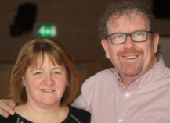

**Upcoming Events**

**September**

**7th – 13th Albania** *A big part of my work is supporting local missionary teams as they minister into difficult situations. This includes spending time with individual families and a ‘Field Forum’ day when the whole ECM Albania and Kosovo team will meet together to discuss and plan how we can best support each other, in reaching out to the Albanian people.*

**13th -17th Slovenia** *meeting SEE Network Partners to focus on making plans for the future development and support of existing partners.*

**18th-24th Bosnia & Serbia** *joining Stuart Rowell to visit existing partners/local church leaders to consider the possibility of having a ‘Pastors to Pastors’ Conference in this new region next year.*

**25th-27th England** *attending International Leadership Team meetings in Gloucester*

**October**

**4th**  **Support Group Meeting**

**6th – 10th Poland** *visiting the Cackowskis,*

*and Sasko and Ania.*

*Miriam will join me .*

**11th -12th Athlone** *ECM Ireland Prayer*

*Retreat*

**13th-17th** **Spain** *Field Leadership Meetings*

**November (Date to be confirmed)**

**Taste of Europe** *Event in Knockconny*

*Baptist Church.*

**Hi Friends,**

**Since our last update there is much to tell you and we hope are encouraged as you read what God is doing through all of us together. Enjoy!**

**Love and Blessings,**

**Charlie and Miriam**

Anderson’s Update

September 2019

**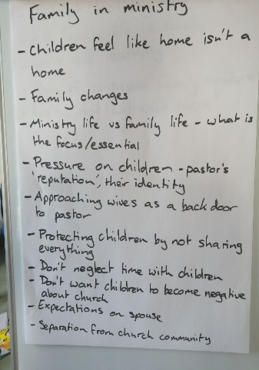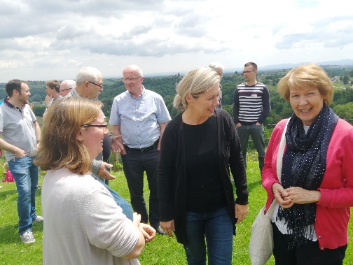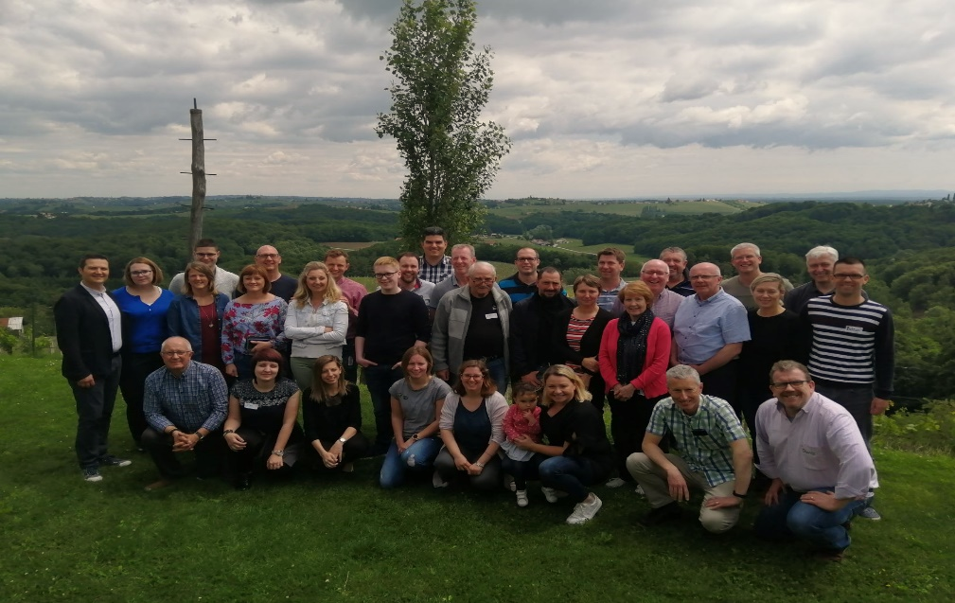

**Pray for ‘Pastors to Pastors’**

**Praise God for positive feedback from the conference. The work was worth it!!** **Pray that new relationships will continue to develop.**

**Results?**

20 National workers met together with 10 N.I. church leaders. A national partner’s friend said *I never knew there was somewhere like this where I could get solid Bible teaching rather than someone telling me how to be enthusiastic in ministry.* **That’s the SEE Network at its best!**

**What happens?**

A 3 day conference in Jerusalem, Slovenia. National partners invite colleagues to study God’s word, have fellowship, hear ministry reports, pray and chat.

The N. Ireland folk go ‘home’ with a partner on Sat. to visit and see their ministry situation on Sun.

We trust God to spark a desire in the N. Ireland leaders to continue contact with the SEE Network fellowships and church plants. Ideally, they will provide the prayer, encouragement and financial support needed but not yet available to these groups.

**What are these?**

Trips which introduce Pastors from N. Ireland and beyond, to national partners in South East Europe ie. for us Slovenia, Croatia, Serbia, Bosnia. We call it the SEE Network as we want to help these christians be part of a group or network which encourages them.

**Pastors to Pastors May ’19 (SEE Network Trip)**

Can you HELP?? P**lease let us know your email address so that we can contact you with our updates more easily and save money on postage. Our contact details are overleaf. If you don’t have an email address don’t worry, that’s fine.**

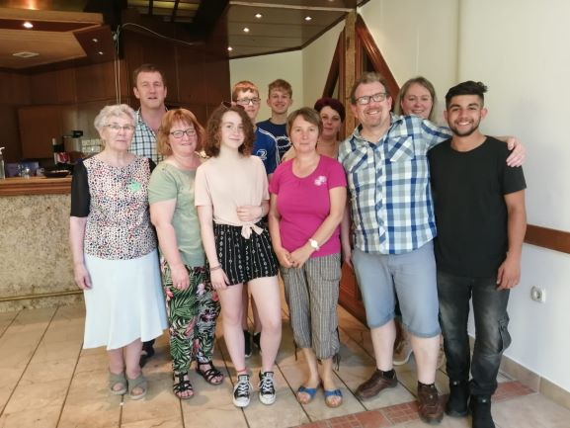



**Changes for Miriam.**

*Having worked for quite a few years in the ECM Office, Lisburn, and last year as Assistant Director during Lindsay’s maternity leave, after much prayer and soul searching; it’s time to move on.* ***I believe God is leading me to continue my responsibilities with ECM International, and to work with Charlie****.*

*I finish work in the office on 9th Oct* ***but will continue in Member Care and the Biennial Planning Team.*** *I also hope also to write up stories of how God is changing lives in Europe.*

***There is also room to help, support, and care for the SEE Network partners, and others with whom Charlie works in countries where field structures are not well developed, or folk are geographically far apart.***

*I’ll be helping to plan trips, manage emails, and promote both the SEE Network, and our ministry, in church and ladies’ meetings.* ***SO! IF YOU WOULD LIKE TO HEAR MORE JUST LET US KNOW***😊

*I am pleased to be focussing on more specific areas of work and am excited to see how God will use me in these areas, but I do feel a little daunted by the prospect of losing the income from my office job****. We are looking to God to provide what is needed to help us finance everyday life and ministry.***

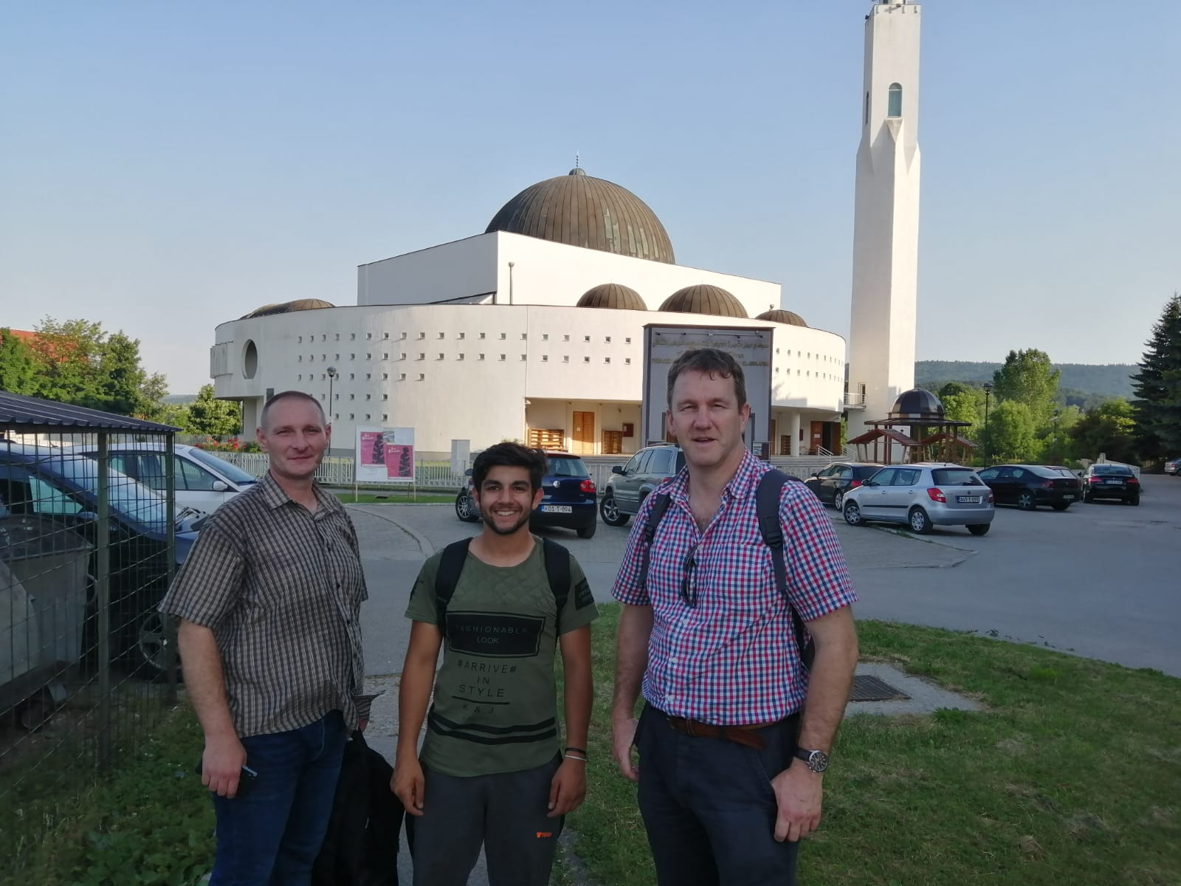

**Pray for US please**

**Praise God for confirming the way forward.**

**Pray for the ability to trust God, through this time and for enough support to be raised so that we can be involved as planned, or in turn for teaching opportunities to open up which could provide us with the necessary finance for life and work.**

***Thank you all for your help and support,***

***Charlie and Miriam***

**Pray for Bosnia**

**Praise God for the freedom to share the gospel and seed sown.**

**Pray for those like Keti, Tea, Adel and his family, who want to worship God and reach out to their neighbours with the message of Jesus.**

**Pray for a house for Adel’s family.**

**For Questions, bookings or anything else please contact us on:**

Miriam [miriam.anderson@ecmi.org](mailto:miriam.anderson@ecmi.org) Mobile/Whatsapp 07853895548

Charlie [charlie.anderson@ecmi.org](mailto:charlie.anderson@ecmi.org) Mobile 07782561208

Office 028 92666044

Website: ecmireland.org

**Bosnia - English Classes and 5 Day Club**

A team of 8 mixed aged folk were in the Muslim town of Bugojno, Bosnia, at the start of July teaching English for 2 hours and God’s Word for 1 hour. We did bible lessons, quizzes, 2 songs in Bosnian, 2 memory verses plus a chorus in English.

Amazingly we had an average of 15 Bosnian teens hearing the gospel every day for 5 days. 2 ladies Keti (a Pastor’s wife), and Tea (Taya- a literature worker), came to translate along with Adel.

Adel (in the black shirt) is the only Christian of his age (17). He has no christian friends his age anywhere in the town, and he postponed going to camp, to be able to help us on the team. He loves the Lord but life is not easy. Adel and his sister’s family have suffered opposition from Muslim family members and neighbours and need God’s help to find and move to a new house so their family (including 3 christian children) can be kept safe.

*Distributing 800 evangelical tracts in the area around the biggest mosque in Bugojno.*